



**SM6P07NI Digital Media Project**

**20% Research and Proposal**

**2023-24 Autumn**

**Student Name:** Sanket Shrestha

**London Met ID:** 22067428

**College ID:** NP01MM4A220103

**External Supervisor:** Rupesh Dangol

**Internal Supervisor** Prabat Bhujel

**Assignment Due Date:** Jan 3

**Assignment Submission Date:** Jan 8

**Word Count: 2382**

**Project File Links:**

|  |  |
| --- | --- |
| **One Drive Link:** | [**Coursework 1**](https://islingtoncollegeedunp-my.sharepoint.com/:f:/g/personal/np01mm4a220103_islingtoncollege_edu_np/Epqi0gsgNyRKq5ERD3QQHRMBa2JVG0jcS4MRZx7_SfiETQ?e=CdQdUY) |

*I confirm that I understand my coursework needs to be submitted online via Google Classroom under the relevant module page before the deadline in order for my assignment to be accepted and marked. I am fully aware that late submissions will be treated as non-submission and a marks of zero will be awarded.*

Abstract

The project is about redesigning and creating a full version of the SpaceChimp.ux website, which is an educational platform offering IT courses, mostly focused on UI/UX design. The main goal is to create a modern, responsive, and user-friendly site that grabs users’ attention while showing off the courses, the instructors, and the benefits of joining. A lot of effort is being put into making the design not just look good but also work well on all devices, like desktop, tablet, and mobile. There’s a big focus on adding smooth transitions, cool animations, and easy navigation to make the site feel engaging and simple to use.

This documentation goes into detail about the research and planning process. It includes topics like user retention, accessibility, and responsive design in the literature review. There’s also an analysis of similar platforms like Skillshare, Broadway Infosys, and CTRL, which helped shape the overall design direction and content structure. The project covers a wide range of steps, including UX research, wireframes, mood boards, information architecture, user personas, user flows, and creating a design system with a style guide. Feedback from the client and supervisor played a big role in refining the design. The testing and evaluation phases are also described to ensure quality.

To keep everything organized, a Gantt chart outlines the timeline for research, design, and development phases, breaking down each task to show how the project will move forward step by step. It’s not just about creating something that looks good but also ensuring it works well for users and meets the project’s overall objectives.

Contents

Section A: Research 1

1. Introduction 1

2. Literature Review 2

1. Important of User Retention 2

2. Accessibility in UX design 3

3. Importance of Visual Hierarchy in UX 4

4. Color Theory in Design 5

5. Typography in Digital Design 6

6. Adaptive Design 7

3. Product Review 8

1. Broadway Infosys Overview 8

2. CTRL 9

3. Helen Macpherson Smith Trust 10

4. Skillshare 11

4. Summary and Conclusions 12

Section B: Project Proposal 13

1 Project Title: Space Chimp 13

2 Research Question 14

3 Treatment 15

4 Resources 16

5 Contribution of Others 18

6 Evaluation & Testing 19

References 20

Appendix 21

**Table of Figures**

Figure 1: Importance of Customer Retention. 2

Figure 2: Accessibility vs Usability. 3

Figure 3: Visual Hierarchy (Venngage, 2022). 4

Figure 4: Psychology of Color (Cameron Chapman, 2018). 5

Figure 5 Typography (Bhatt, n.d.). 6

Figure 6: Adaptive Design (geeksforgeeks, 2022). 7

Figure 7: Broadway Infosys Landing Page. 8

Figure 8: Broadway Courses layout 8

Figure 9: CTRL Viewport. 9

Figure 10: CTRL Section Layout. 9

Figure 11: Hmstrust Landing Page. 10

Figure 12: Hmstrust Impact Story Section. 10

Figure 13: Skillshare Courses Layout. 11

Figure 14: Figma logo. 16

Figure 15: Jitter Logo. 16

Figure 16: After Effects Logo. 17

Figure 17: Gantt Chart 21

# Section A: Research

## Introduction

In this coursework we need to do research and propose a digital media project (2000-2500 words). On a specific area of interest, where there needs to do both academic literature research and media products research and develop a detailed project proposal.

The concept is to redesign SpaceChimp’s website, a website that offers IT courses. Currently they only have a home page. By providing a complete platform that is both useful and aesthetically pleasing, this project seeks to close the gap between students and top-notch design education.

With modern design aesthetics and responsive layouts, it connects learners to a world-class IT education that bridges the gap between them. It features intuitive user interaction with clear navigation and detailed course information, so users can find courses to enroll in and satisfy their career aspirations. The aim of this project, therefore, is to increase the accessibility, responsiveness, and thoughtful design of SpaceChimp to establish itself online as a leading force in digital education.

## Literature Review

### Important of User Retention

User retention is the number of people who interact with a product or service over a period. Measuring user retention helps brands understand how much value they are providing to users (Fortugno, 2024).

User retention is important because it helps to ensure long term engagements, reduces acquisition costs and build brand loyalty which will help to a sustained growth and success.

To Increase user retention, the following things could be done: -

* Simplify onboarding process
* Provide personalize user experience
* Give priority to customer service
* Take user feedback to improve your product/services
* Send push notification to announce something new or remind user about your product or service
* Gamify the user experience

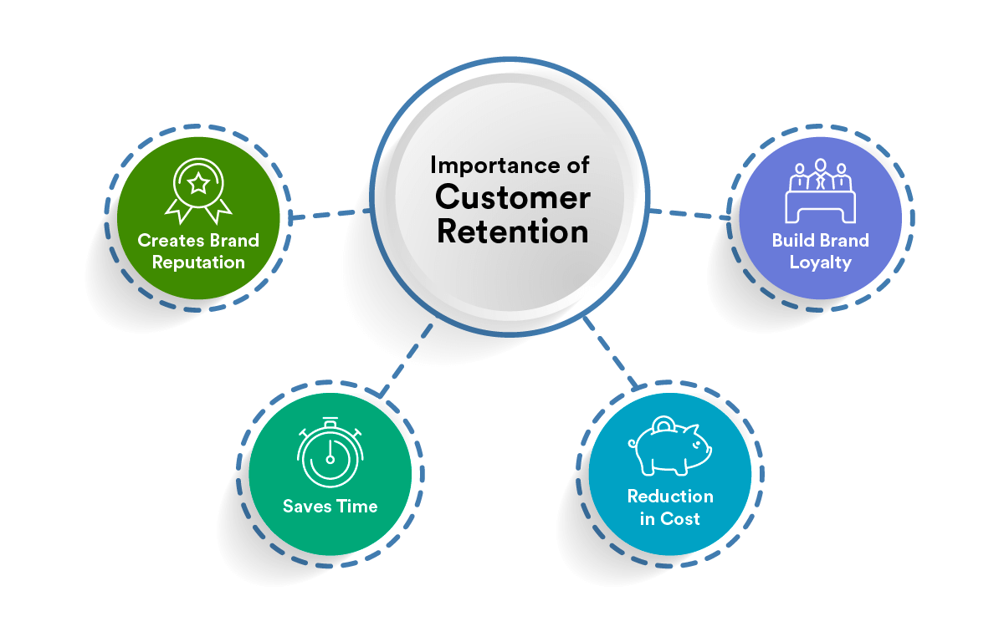

Figure : Importance of Customer Retention.

### Accessibility in UX design

Accessibility in UX design is the practice of designing products and services for users of various abilities. Accessible products and services make all users feel included and understood, regardless of their abilities, context, or situation (Tomboc, 2024).

Accessibility in UX design is important because it promotes inclusivity, Improves usability, Increases user base and Boosts SEO rankings. Also it aims to level the playing field.

Some key principles for accessible design are as follows: -

* By using alt text for images, videos and icons so that users who rely on screen readers will be able to understand content
* Ensuring sufficient contrast in text and background to make content easily readable for users with visual impairments
* Providing keyboard navigation so that users with mobility impairments can use a website without relying on a mouse
* Using simple and clear language helps users with cognitive disabilities to understand content easily

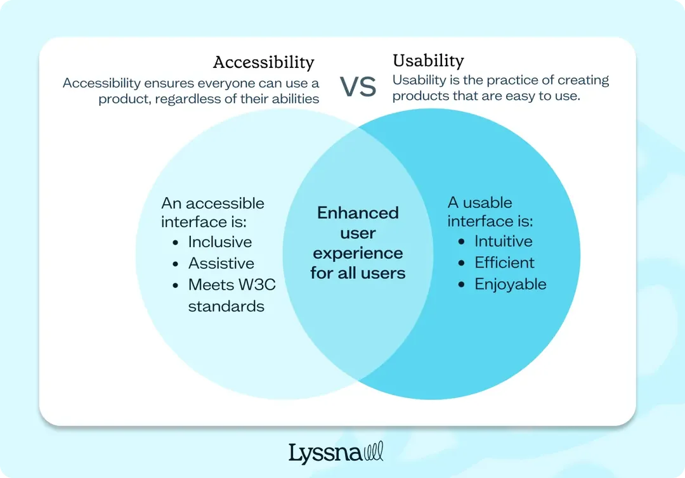

Figure : Accessibility vs Usability.

### Importance of Visual Hierarchy in UX

Visual hierarchy in web design is crucial as it organizes design elements in order of importance, directing user focus. It employs size, color, contrast, and space to delineate priority, guiding users effortlessly through the content and ensuring a harmonious, intuitive user experience (Interaction Design Foundation, 2016).

Visual hierarchy is important because it helps users to navigate easily. Better visual hierarchy helps to guide the eye, it reduces cognitive effort, prevents confusion and improves user experience.

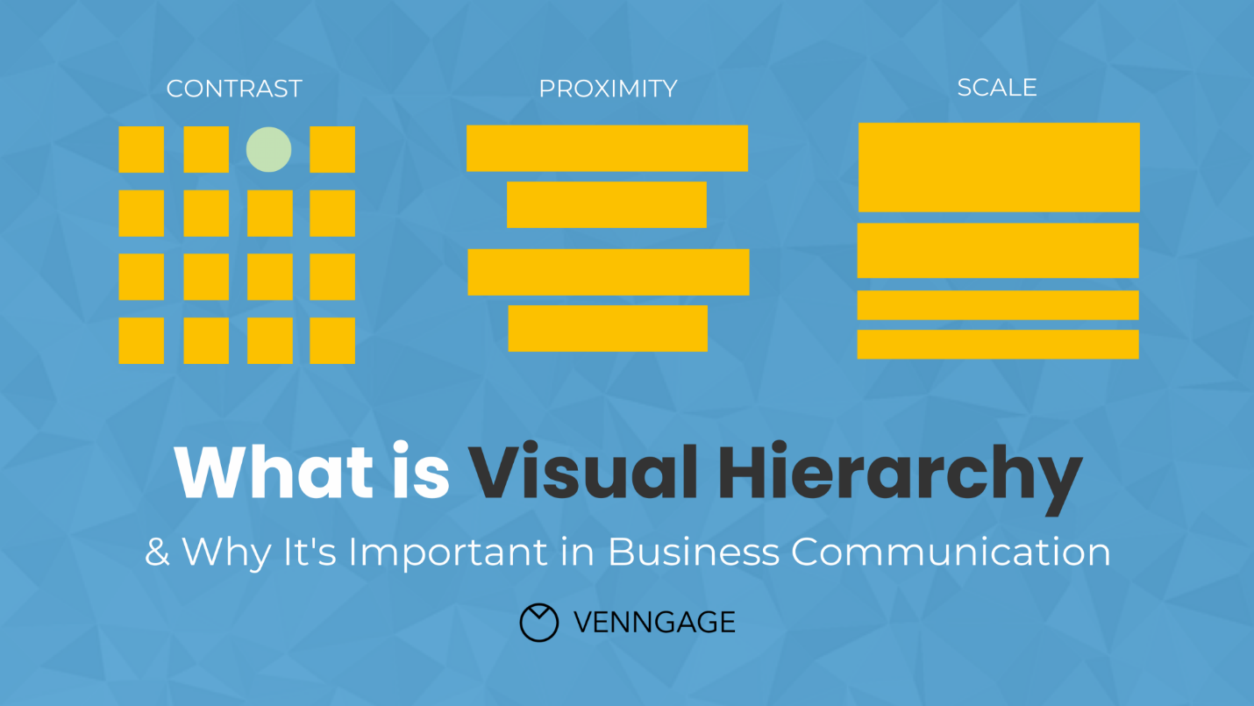

Figure : Visual Hierarchy (Venngage, 2022).

### **Color Theory in Design**

Understanding color psychology in UX design is a key aspect of creating a color palette that works well in for users. While color is sometimes thought of as a purely aesthetic choice by some designers, it is, in fact, a key component of the psychological impact of a design on users, and as such, its UX (Cameron Chapman, 2018).

Color theory is important because it helps to create a visual appealing design. Different color has different psychological impacts with color we can set the tone of design. Also, color plays a vital role in accessibility. We need to follow WCAG guidelines to ensure that our design is easily accessible for all users. For SpaceChimp, vibrant and balanced color will be used to convey professional yet welcoming atmosphere.

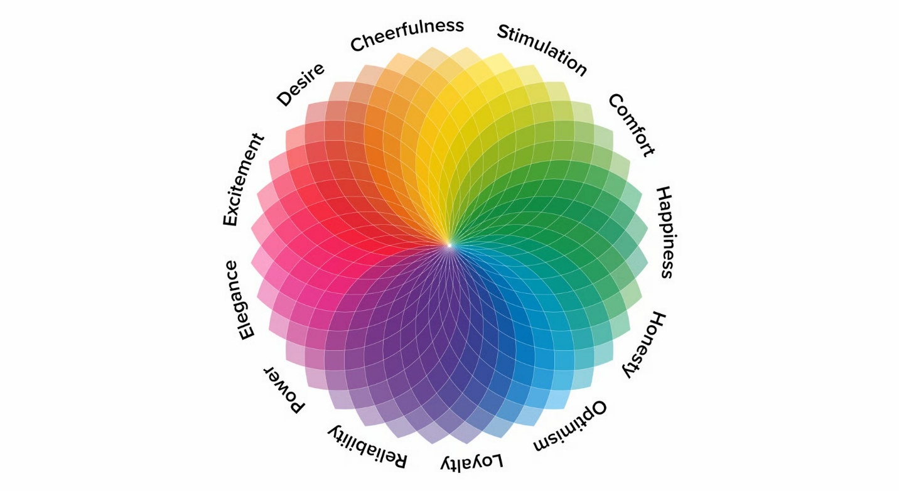

Figure : Psychology of Color (Cameron Chapman, 2018).

### Typography in Digital Design

Typography is a design discipline that involves the use of typefaces and the organization of those typefaces to create readable, usable and ideally, user-friendly interfaces or experiences. Effective typography enhances UX, optimizes usability, catches users’ attention and has the potential to increase conversion rates (Tlitz-Patrick, 2022).

Typography is important in UX design because it make how user perceive and interact with content. A good typography will make a design easily readable, maintain hierarchy and conveys the tone and personality of a design. For SpaceChimp San-Serif fonts will be used to ensure readability and professionalism.

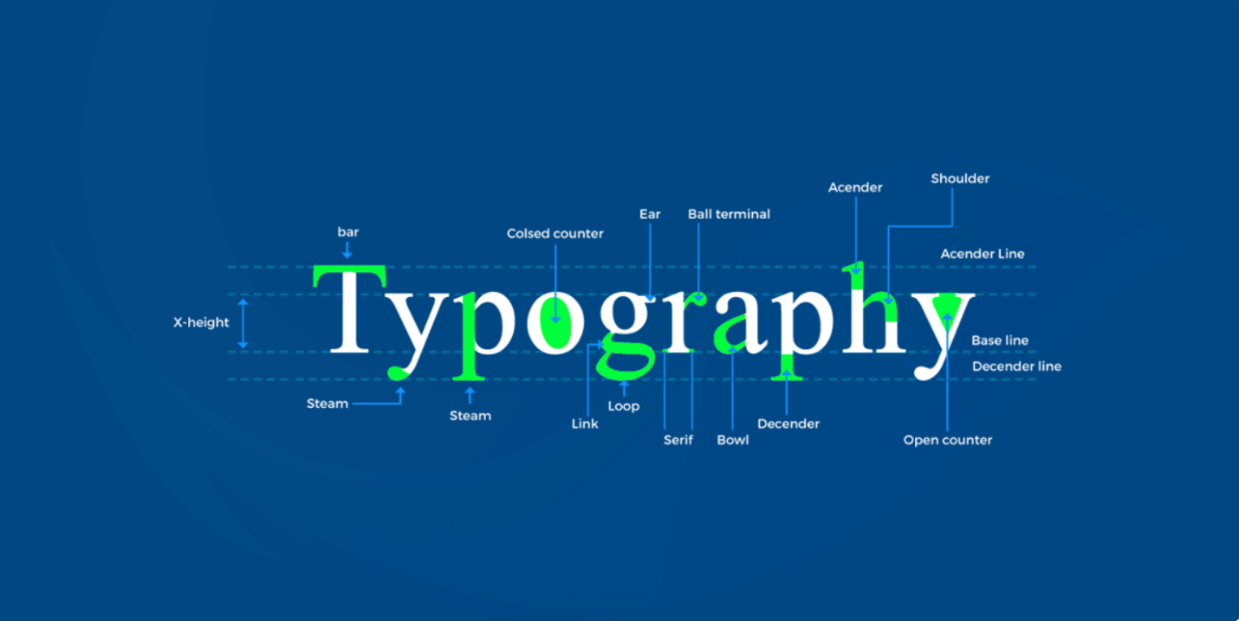

Figure Typography (Bhatt, n.d.).

### Adaptive Design

An adaptive design approach makes a website usable on any size screen and across all device types, such as mobiles, tablets, desktops, and laptops (Dovetail Editorial Team, 2023).

I’m designing the SpaceChimp’s website for Desktop, Tablets and Mobile view. It helps to display effectively on all devices. Also, it helps to improve user experience and reduce website load time.

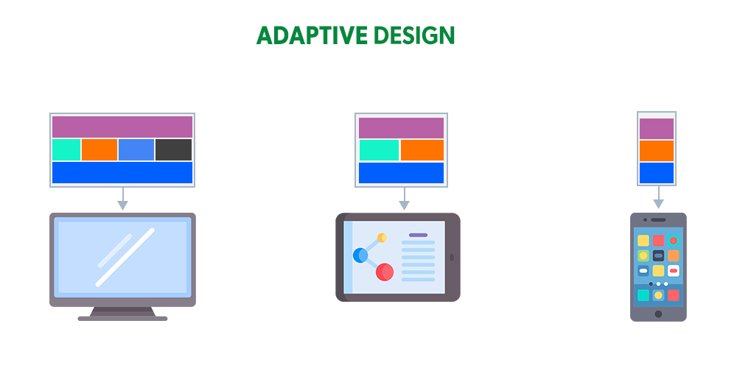

Figure : Adaptive Design (geeksforgeeks, 2022).

## Product Review

### Broadway Infosys Overview

Broadway Infosys is a successful educational institute in Nepal. They provide IT courses both online and physical classes. There website is well maintained with proper structure and clear presentation of information. Since Broadway Infosys are here from the long-time their content arrangement can be inspiration for SpaceChimp’s website. They also have well placed CTA buttons.  
Website Link: - <https://broadwayinfosys.com/>

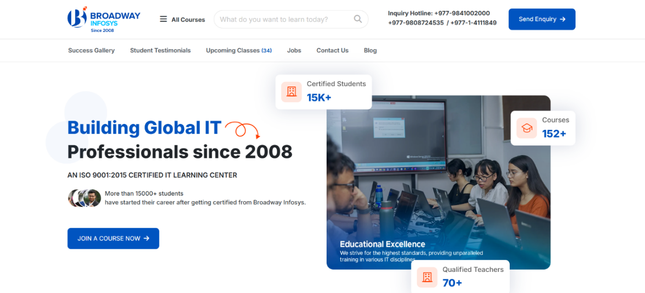

Figure : Broadway Infosys Landing Page.

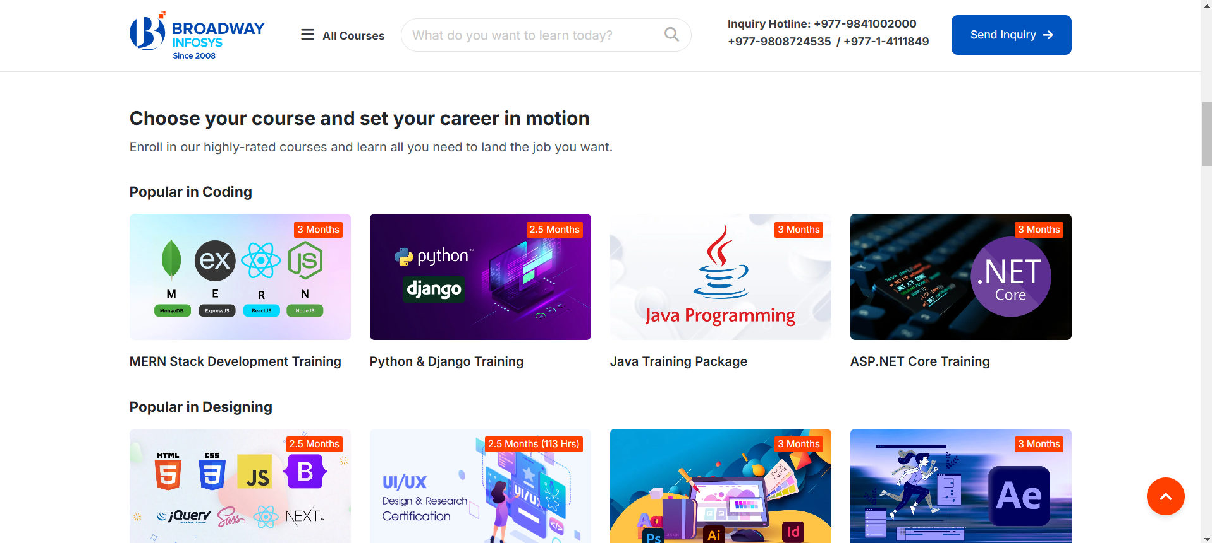

Figure : Broadway Courses layout

### CTRL

CTRL is a design studio website. They have cool animations and clean user interface. Their website tell about the power of animation on a website creating a highly engaging user experience. After reviewing their website I have learned how motion can help in storytelling. Also where I could use motion for visual hierarchy, like I could highlight important section like available course in space chimp or CTAS.

Website Link:- <https://ctrl.xyz/>

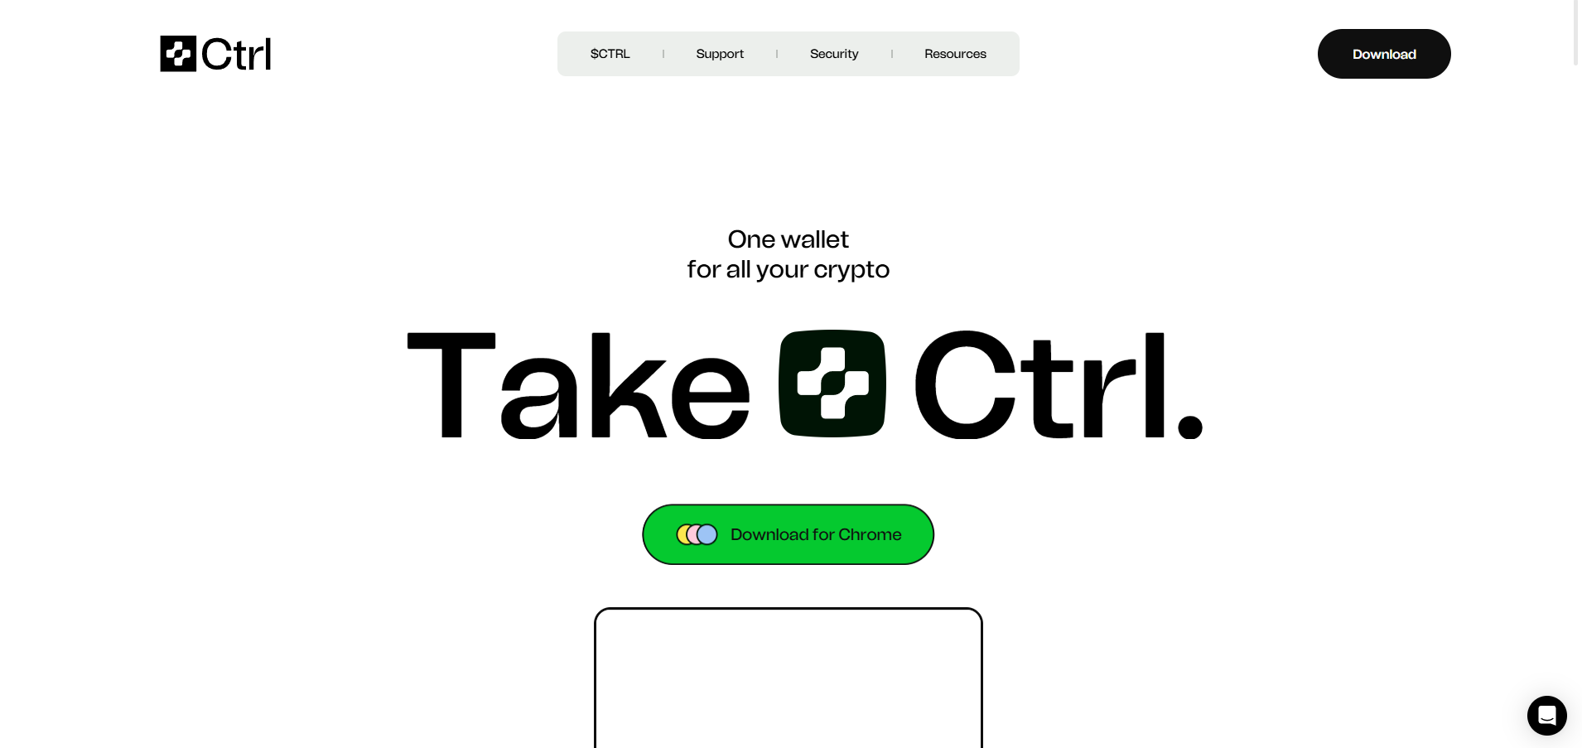

Figure : CTRL Viewport.

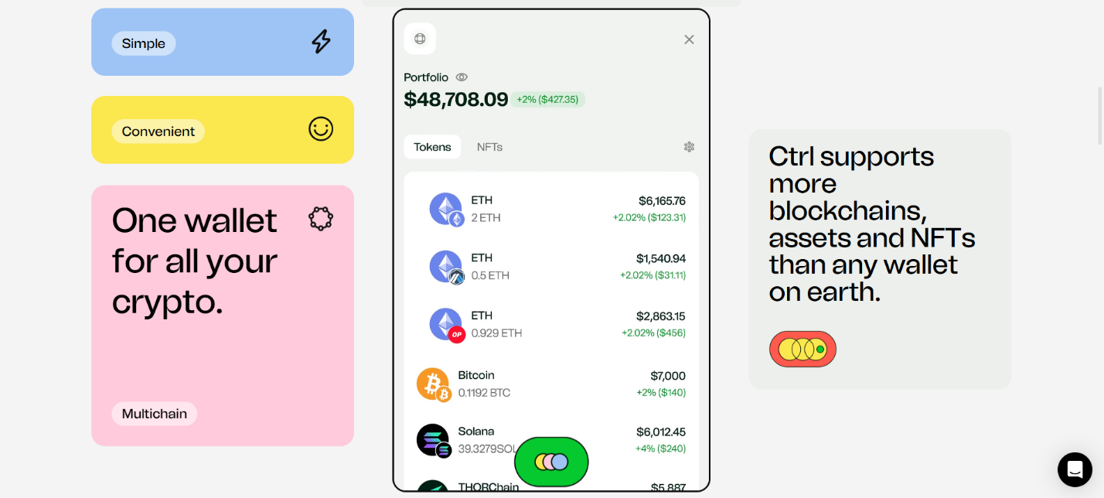

Figure : CTRL Section Layout.

### Helen Macpherson Smith Trust

The Helen Macpherson Smith Trust website have a visual appealing color palette. Which makes this site engaging without overwhelming the user. This website tells me about the color hierarchy since space chimp also have vibrant palette, I can use their color hierarchy technique to visually distinguish sections and prioritize contents.

Website Link: - <https://hmstrust.org.au/>

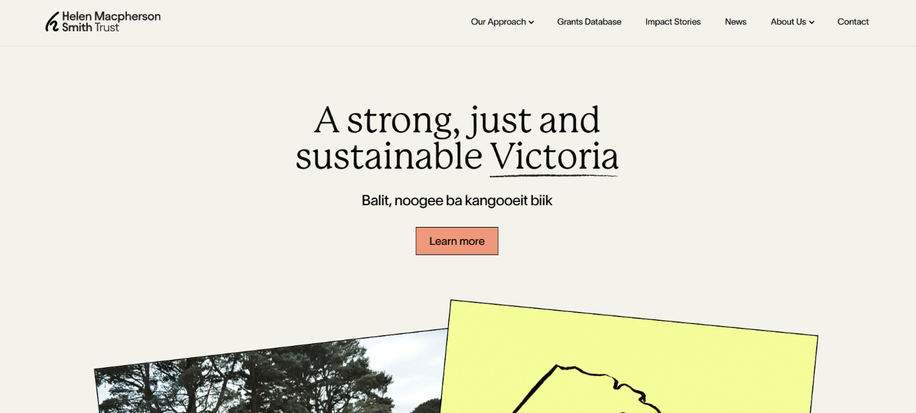

Figure : Hmstrust Landing Page.

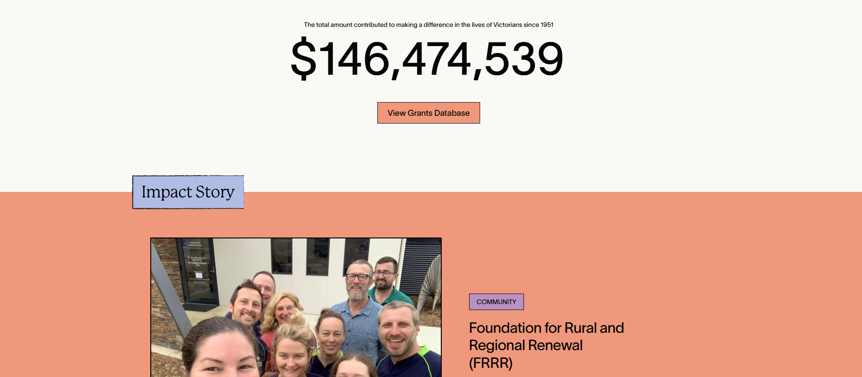

Figure : Hmstrust Impact Story Section.

### Skillshare

Skillshare is one of the online educational platform in international market, they have a wide range of courses for creative and professional fields. They have set a benchmark for providing an excellent learning experience. Their user centric design, engaging visuals, color usage and almost everything is very valuable for me to build a website with seamless user experience for SpaceChimp.

Website Link: - <https://www.skillshare.com/en/>

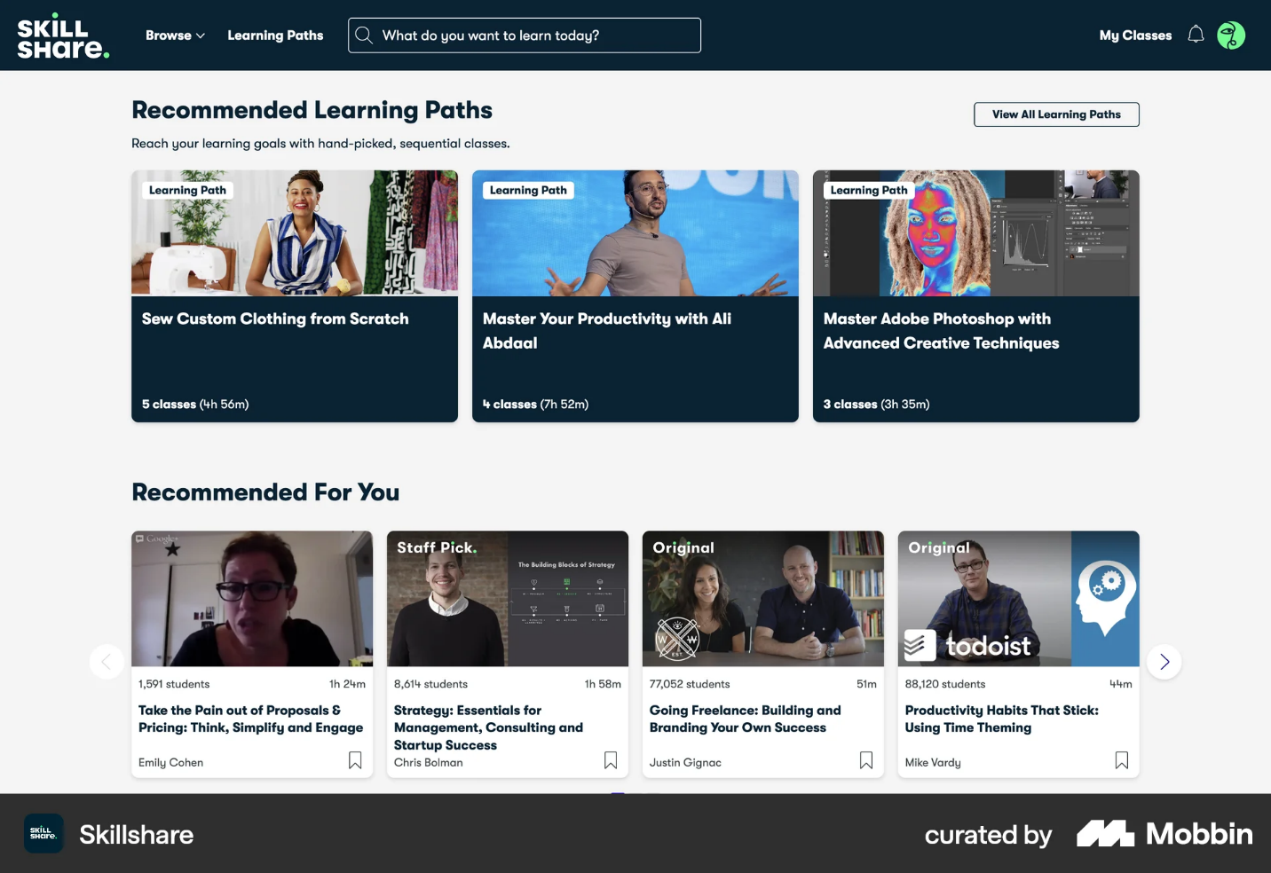

Figure : Skillshare Courses Layout.

## Summary and Conclusions

Based on research into Importance of user retention, accessibility, and visual hierarchy, leading UX principles, and reviews of Skillshare, CTRL, Broadway Infosys, and HMSTrust educational websites, the key components of making a successful educational website will rely on user-centered design, easy-to-follow navigation, and captivating graphics.

SpaceChimp is unique in that it's UI/UX-driven; it combines bold animations inspired by CTRL with color harmony from HMSTrust and structured content from Skillshare, which is complemented by Broadway Infosys. This local yet innovative approach ensures that SpaceChimp appeals to its target audience while offering a fresh perspective in a competitive market.

# Section B: Project Proposal

## Project Title: Space Chimp

SpaceChimp is an educational platform for IT courses. This project is about designing a website for SpaceChimp with a responsive interface for desktop, table and mobile view. This will be executed with enough research and planning in a professional way. It will also contain detailed UX research, information architecture (IA), mood boards, user flows, user personas, and a proper design system with a style guide. Starting from wireframes, it will be used as a guideline in developing the final design. The final design of the website that comes after the wireframes has especially considered transitions and animations to make it user-friendly and visually appealing for ensuring user satisfaction. The main aim of this website is to enroll interested students in space chimp’s courses.

## Research Question

**How can responsive, adaptive, and accessible design collectively improve user engagement and inclusivity on educational websites?**

A responsive and adaptive design, complemented with accessibility in mind, can significantly improve the engagement of users toward educational websites.

The reason is that a **responsive design** ensures the contents will correctly adapt to several sizes of screens and supply only one experience, either on desktop, tablet, or mobile device. **Adaptive design** is all about tailoring the layouts to specific devices for a personal touch in user experience and making navigation fun and intuitive.

Inclusive in the process, it includes principles of accessibility—such as proper color contrast, keyboard navigation, and compatibility with screen readers—that will make educational content accessible to all users, including people with disabilities. This brings in trust and encourages continued engagement.

**Better Learning Experience**

Responsive and adaptive designs guarantee that users can easily access learning materials from any environment, while accessibility features help to cater to different user needs, eliminating any barriers to engagement.

**Retaining Users Through Engagement**

The visual look, user-friendliness, and inclusiveness of a site keep customers longer, increasing retention and inviting revisits to the site.

## Treatment

.Upon opening space chimp website, a simple navigation and a hero text can be seen encouraging to enroll in their courses. Scrolling further through the website, Space Chimp about section can be seen, furthermore a layout featuring courses such as UI/UX Desing, motion graphics and coding can be seen with proper description and important details. Navigation feels effortless on a desktop, tablet, or mobile device, allowing users to easily explore courses, instructor profiles, and detailed modules. The website also provides course details, including modules to be covered and instructor profiles with their expertise. It also includes resources, like blogs and tips, that help students improve their experience, which makes the process of learning whole and interactive while catering to their needs.

## Resources

Required Hardware: a laptop with following specs: -

* NVIDIA GeForce GTX 1660 Ti
* AMD Ryzen 7 4800H with Radeon Graphics

Required Software’s: -

* **Figma**: It will be used to create IA, Wireframing, High-Fidelity Design and Prototyping)
* **Jitter:** It will be used to create visual appealing animations
* **After Effects:** It will be used to create complex animations

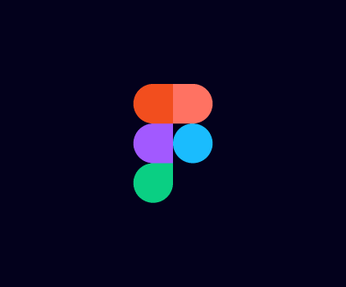

Figure : Figma logo.



Figure : Jitter Logo.



Figure : After Effects Logo.

## Contribution of Others

The client has been supportive in by providing all key assets like brand guidelines, course details, and also giving feedback that are part of the critical direction of this project to meet expectations. These inputs refined the design process and directed it toward alignment with the platform's objectives. The continuous advice coming from my internal and external supervisor played a critical role in this project, for example, making improvements and maintaining standards to meet industrial standards. These will altogether bring a major impact on the project and its quality.

## Evaluation & Testing

A detailed usability test will be conducted to check that the design of SpaceChimp meets user needs and expectations. This consists of user testing sessions in which participants will use the prototype on desktop, tablet, and mobile devices to uncover usability issues and also fill-up a google form. From these sessions feedback will be noted from participants and implement them in the design of SpaceChimp.

Also, feedback will be taken from my mentors and friends to check the design concepts and user flow. This will help me to identify area for improvement and show the final design with seamless and engaging user experience.

# References

(2016, Aug 31). Retrieved from Interaction Design Foundation: https://www.interaction-design.org/literature/topics/visual-hierarchy#:~:text=Visual%20hierarchy%20in%20web%20design,a%20harmonious%2C%20intuitive%20user%20experience.

(2022, Jun 21). Retrieved from geeksforgeeks: https://www.geeksforgeeks.org/difference-between-responsive-design-and-adaptive-design/

(2022, Jul 27). Retrieved from Venngage: https://venngage.com/blog/visual-hierarchy/

(2024). Retrieved from Figma: https://www.figma.com/resource-library/ui-design-principles/

(2024). Retrieved from Laws of UX: https://lawsofux.com/

Bhatt, G. (n.d.). Retrieved from StatusNeo: https://statusneo.com/typography-a-guide-to-make-effective-fonts-for-readability-and-visual-appeal/

Cameron Chapman. (2018). Retrieved from Toptal: https://www.toptal.com/designers/ux/color-in-ux

Dovetail Editorial Team. (2023, may 19). Retrieved from Dovetail: https://dovetail.com/ux/adaptive-design/#:~:text=An%20adaptive%20design%20approach%20makes,finds%20the%20best%2Dfit).

Fortugno, A. (2024, May 26). Retrieved from NOGOOD: https://nogood.io/2024/03/26/user-retention/#1

Tlitz-Patrick. (2022, Jan 24). Retrieved from https://www.interaction-design.org/literature/article/the-ux-designer-s-guide-to-typography

Tomboc, K. (2024, Nov 29). Retrieved from https://www.lyssna.com/blog/accessibility-in-ux-design/

# Appendix

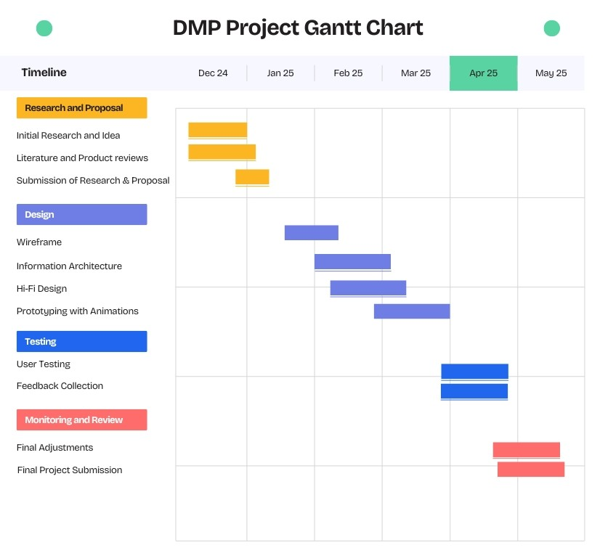

Figure : Gantt Chart

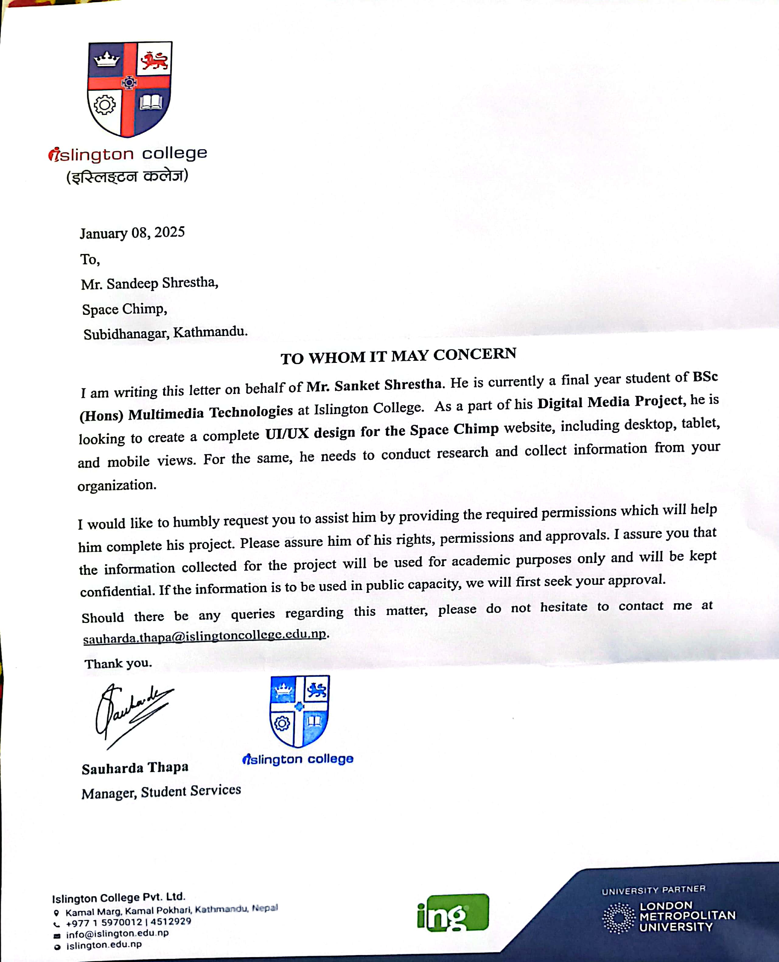

Figure : Client Proposal Letter

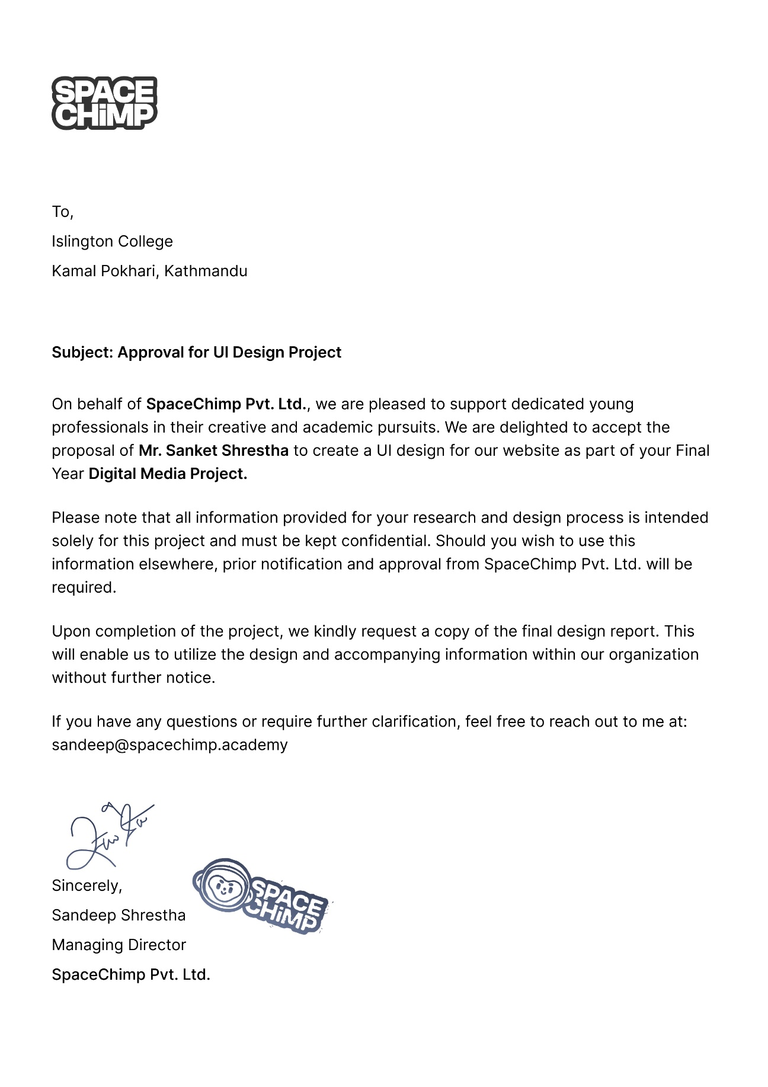

Figure : Client Approval Letter

